Name: GeethaMadhuri Vemulapalli

StudentId: W1094040

Submitted Files:

1. createdb.sql

2. dropdb.sql

3. Populate.java

4. Hw3.java

Running the programs:

Populate,java

javac -classpath sdoapi.jar:ojdbc6.jar Populate.java

java -classpath ojdbc6.jar:. Populate building.xy hydrant.xy firebuilding.txt

Hw3.java

javac -classpath sdoapi.jar:ojdbc6.jar Hw3.java

java -classpath .:sdoapi.jar:ojdbc6.jar Hw3

Query3

For query 3 for OHE building it is taking time to load I am getting only partial outline for the Ohe building. If I wait for about 10 minutes then I am getting the entire outline.

So, could you please wait for 10 minutes after running the query3 and please check it out after 10 minutes.

Initially the GUI is showing up like this

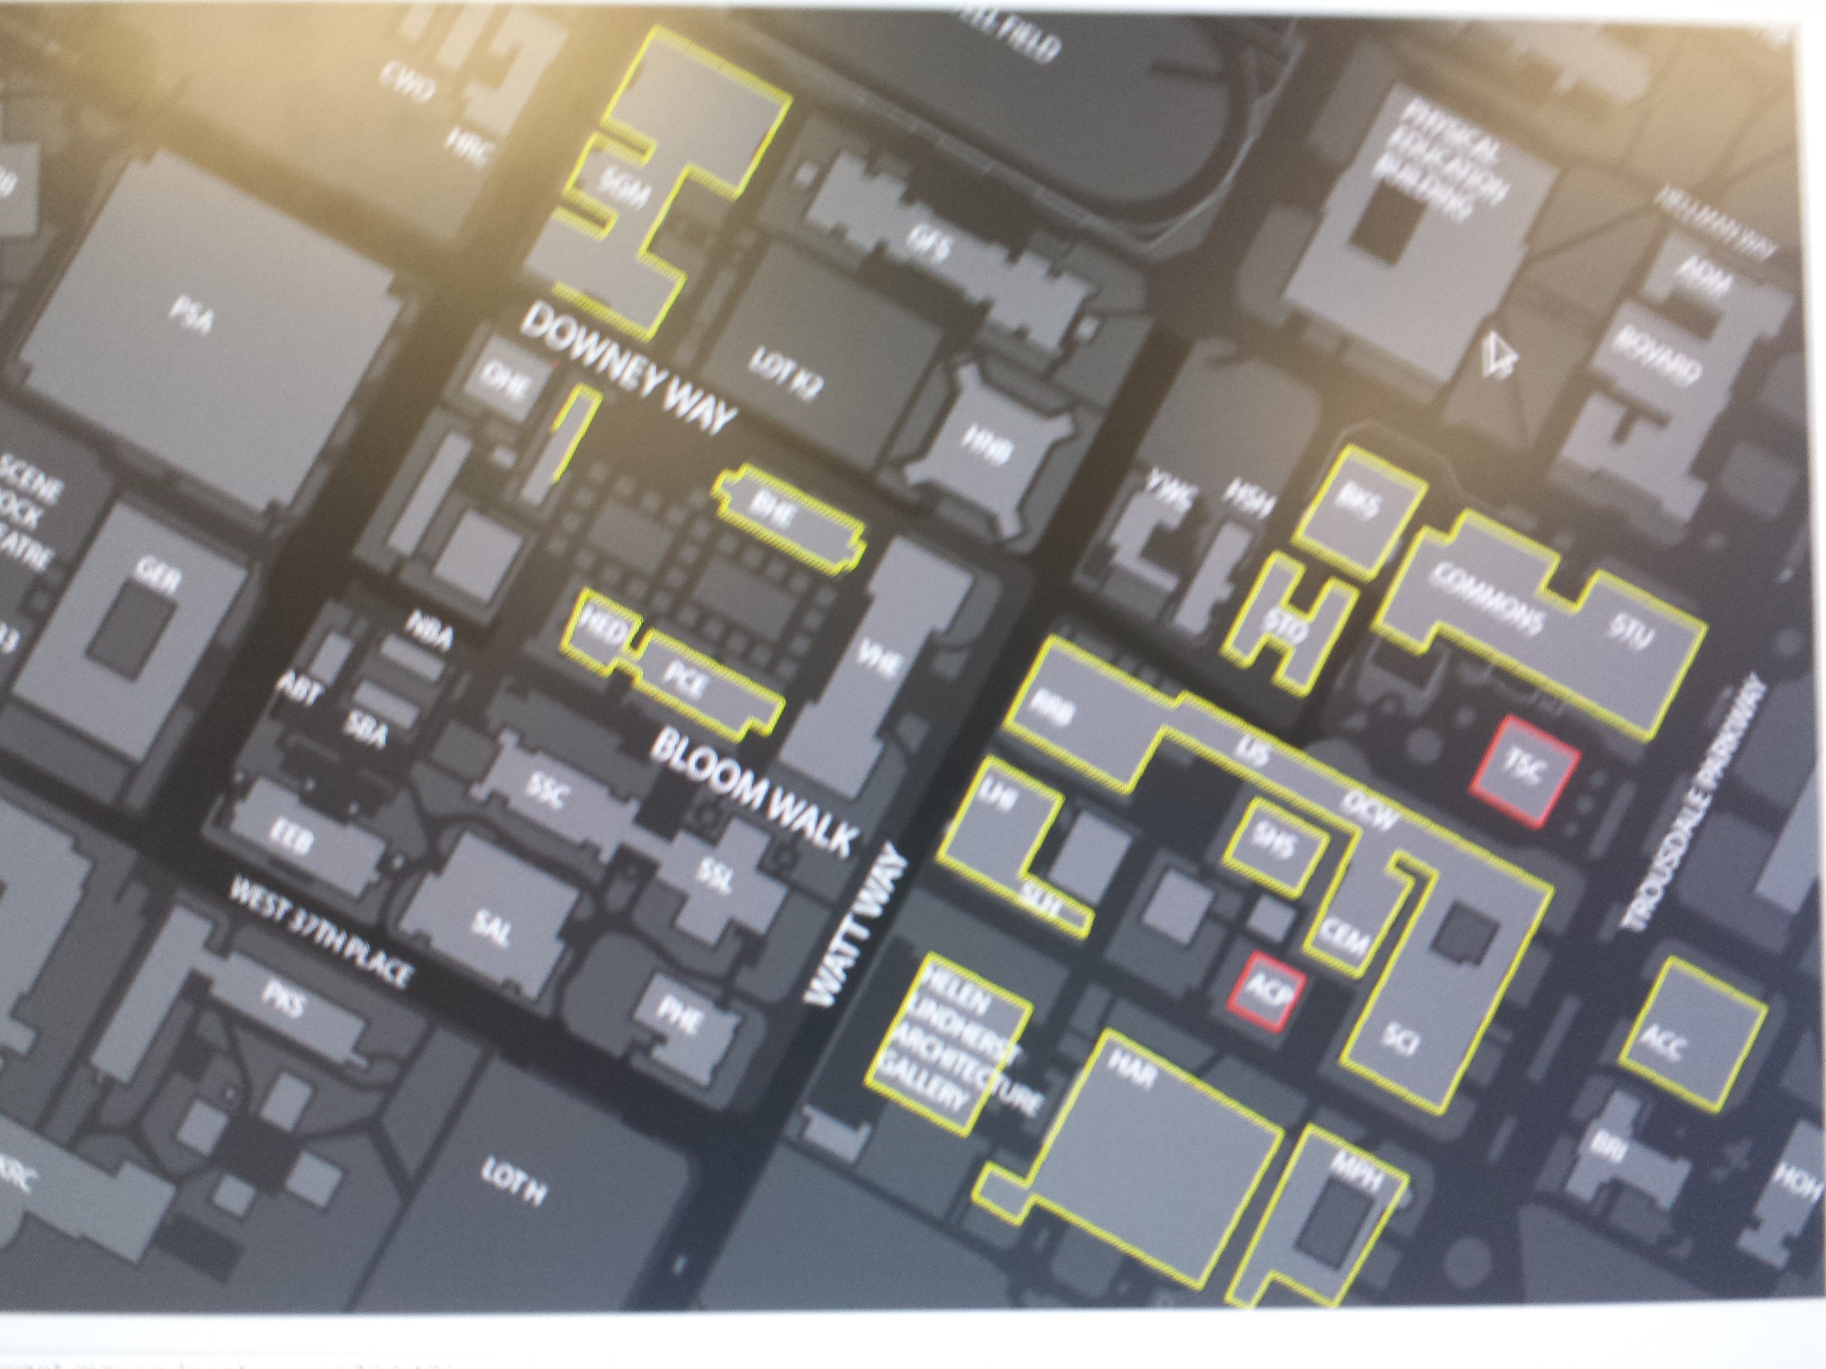

After some time I am getting it like this

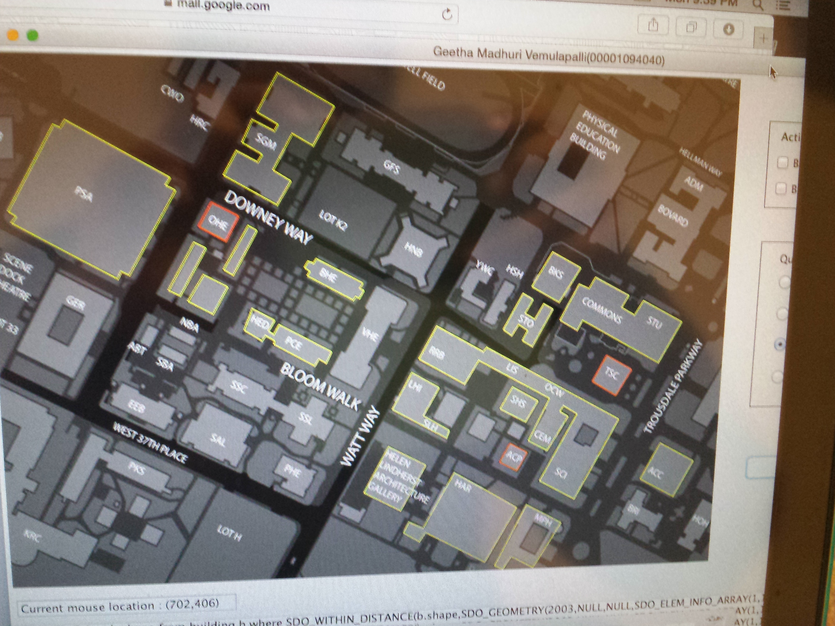

This is the case when I tested it on dc machine. But its working fine in my local machine.

I asked the professor regarding this. Then he suggested me to attach these image files in my readme.txt.

Query 4

For query 4 if you want multiple buildings please click on the submit button each time you click on a building for the nearest hydrants to be displayed.